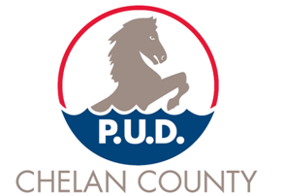

Procurement and Contracting Manager

Supplemental Essay Questions

In order to get a better sense of your writing skills and additional insights into your experience, please answer the following questions. Limit your responses to no more than a single page per question and upload your answers as part of your online application by February 28, 2021 (first review, open until filled).

1. What have you learned about Chelan County PUD and this position that makes you interested in applying, and why is now a good time in your career to consider this position?

- Please give a brief overview of your experience developing and executing contracts.

