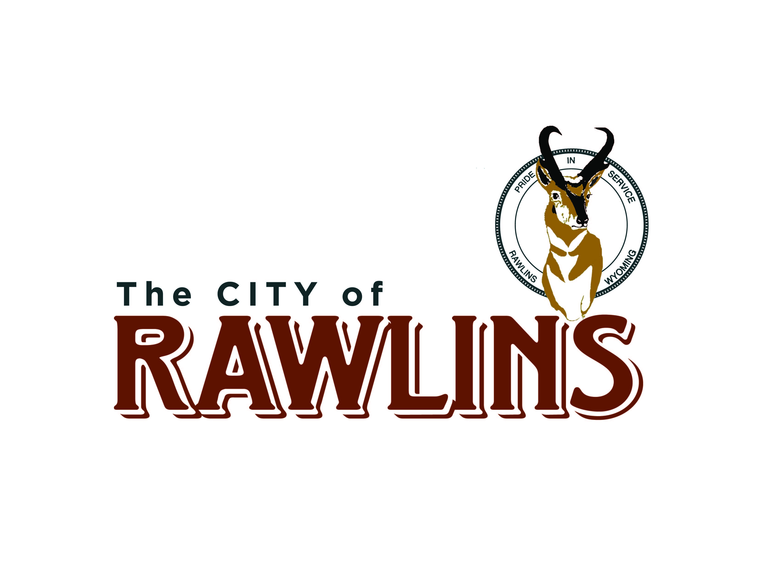
WYOMING

City Manager

Supplemental Essay Questions

In order to get a better sense of your writing skills and additional insights into your experience, please answer the following questions. Limit your responses to no more than a single page per question and upload your answers as part of your online application by March 19, 2023 (first review, open until filled).

- Please tell us why you are interested in this position and why it is a good time in your career to come to the City of Rawlins.

- The City Manager will communicate city successes to the community, promote positive use of social media and develop positive relationships with the local media. Please describe your experience in these areas.

