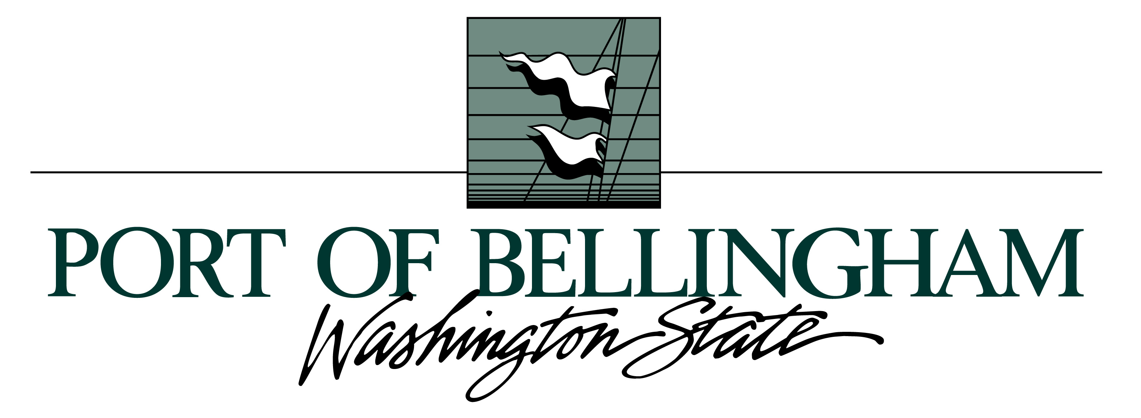

Marine Terminal Business Development Manager

Supplemental Essay Questions

In order to get a better sense of your writing skills and additional insights into your experience, please answer the following questions. Limit your responses to no more than a single page per question and upload your answers as part of your online application by April 9, 2023 (first review, open until filled).

1. Please tell us why you are interested in this position and why it is a good time in your career to come to the Port of Bellingham.

- The person in this position will work independently to established relationships in the shipping industry and continually work on and strengthen these relationships, yet will need to align their skills and goals with the Port's mission and goals and be a team player ensuring everyone is consistently on the same page. How do you go about ensuring this balance is maintained?

