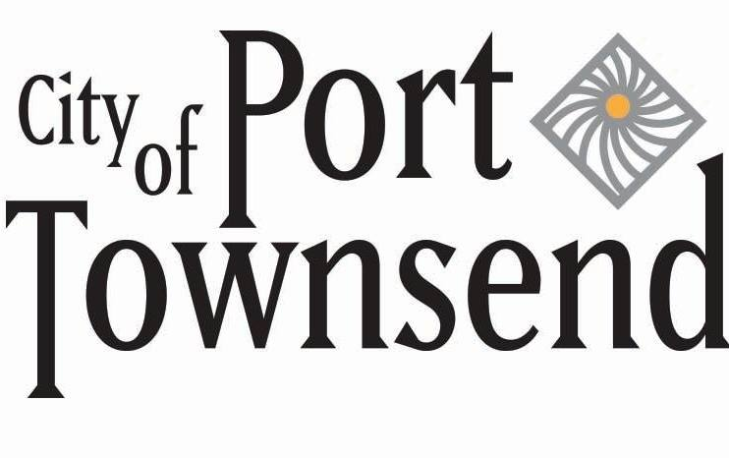

Deputy Public Works Director/City Engineer

Supplemental Essay Questions

In order to get a better sense of your writing skills and additional insights into your experience, please answer the following questions. Limit your responses to no more than a single page per question and upload your answers as part of your online application by August 20, 2023 (first review, open until filled).

- Please tell us why you are interested in this position and why it is a good time in your career to come to the City of Port Townsend.

