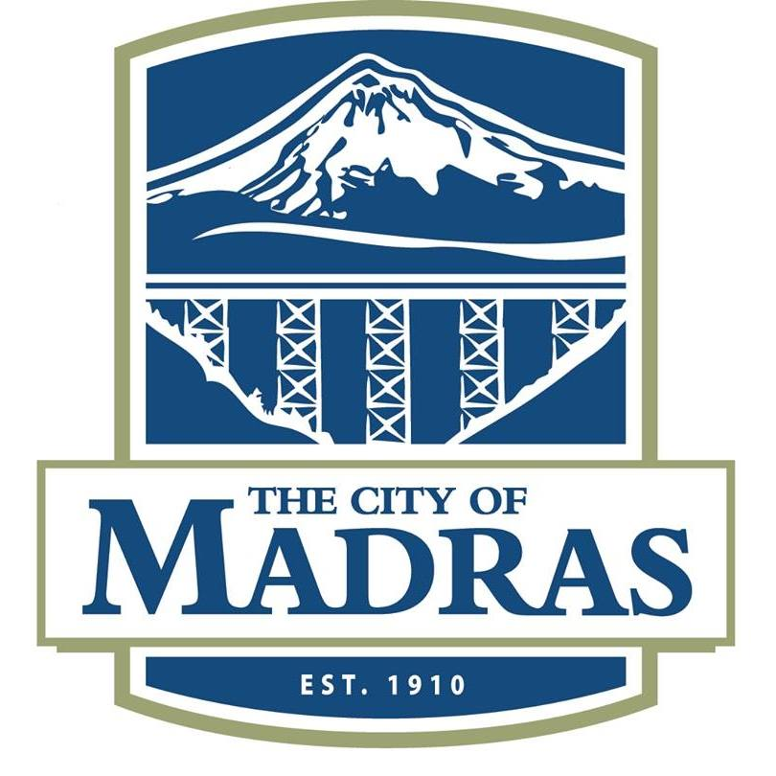
OREGON

City Administrator

Supplemental Essay Questions

In order to get a better sense of your writing skills and additional insights into your experience, please answer the following questions. Limit your responses to no more than a single page per question and upload your answers as part of your online application by August 6, 2023 (first review, open until filled).

1. What have you learned about the City of Madras that makes you interested in this position, and why is now a good time in your career to consider applying for this position?

- Madras continues to see steady growth which presents opportunities and challenges in maintaining and upgrading the infrastructure of the City to adequately sustain the population. What is your experience working within a growing City, and what steps or projects were you a part of which helped pave the way towards successful continued growth?

