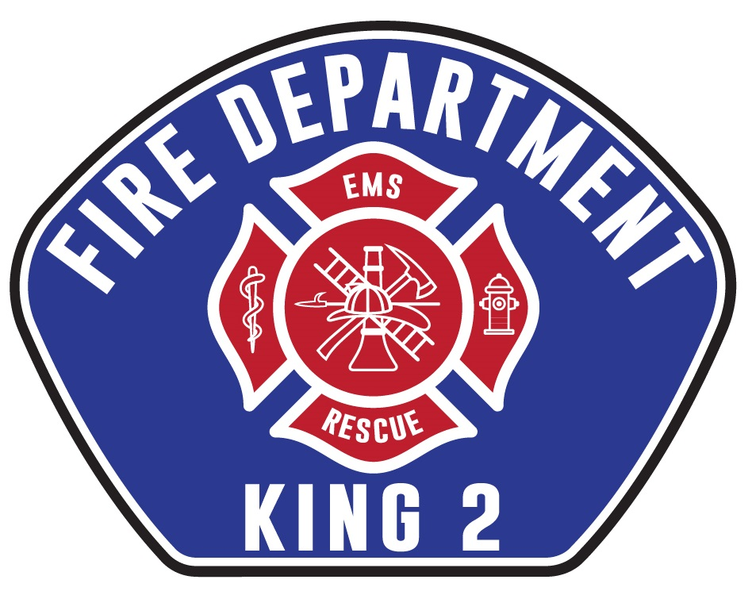

Finance Manager

Supplemental Essay Questions

In order to get a better sense of your writing skills and additional insights into your experience, please answer the following questions. Limit your responses to no more than a single page per question and upload your answers as part of your online application by July 30, 2023 (first review, open until filled).

- Please tell us why you are interested in this position and why it is a good time in your career to come to King County Fire District #2.

- KCFD2 is considering replacing two stations in the coming years, and planning for the finances of those undertakings will be a critical responsibility of the incoming Finance Manager. Please give a brief overview of your experience in financial planning for large projects which would allow you to be successful in this position.

