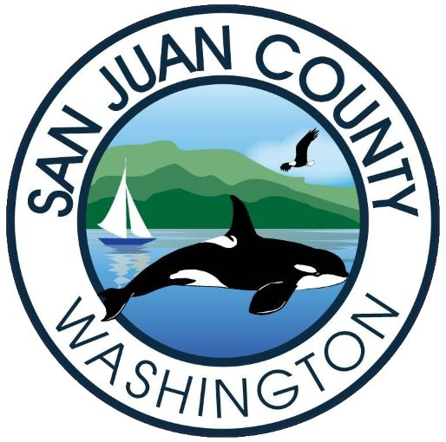

Community Development Director

Supplemental Essay Questions

In order to get a better sense of your writing skills and additional insights into your experience, please answer the following questions. Limit your responses to no more than a single page per question and upload your answers as part of your online application by August 27, 2023 (first review, open until filled).

1. Please tell us why you are interested in this position and why it is a good time in your career to come to San Juan County?

