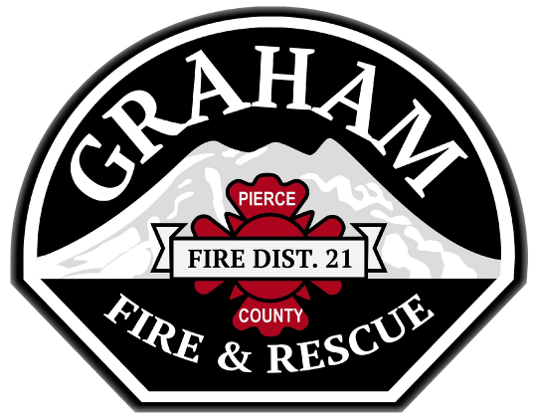

Financial Specialist

Supplemental Essay Questions

In order to get a better sense of your writing skills and additional insights into your experience, please answer the following questions. Limit your responses to no more than a single page per question and upload your answers as part of your online application by August 27, 2023 (first review, open until filled).

- What have you learned about Graham Fire & Rescue and this position that interests you, and why is now a good time in your career to consider this position?

