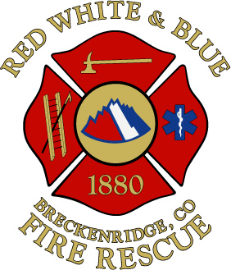
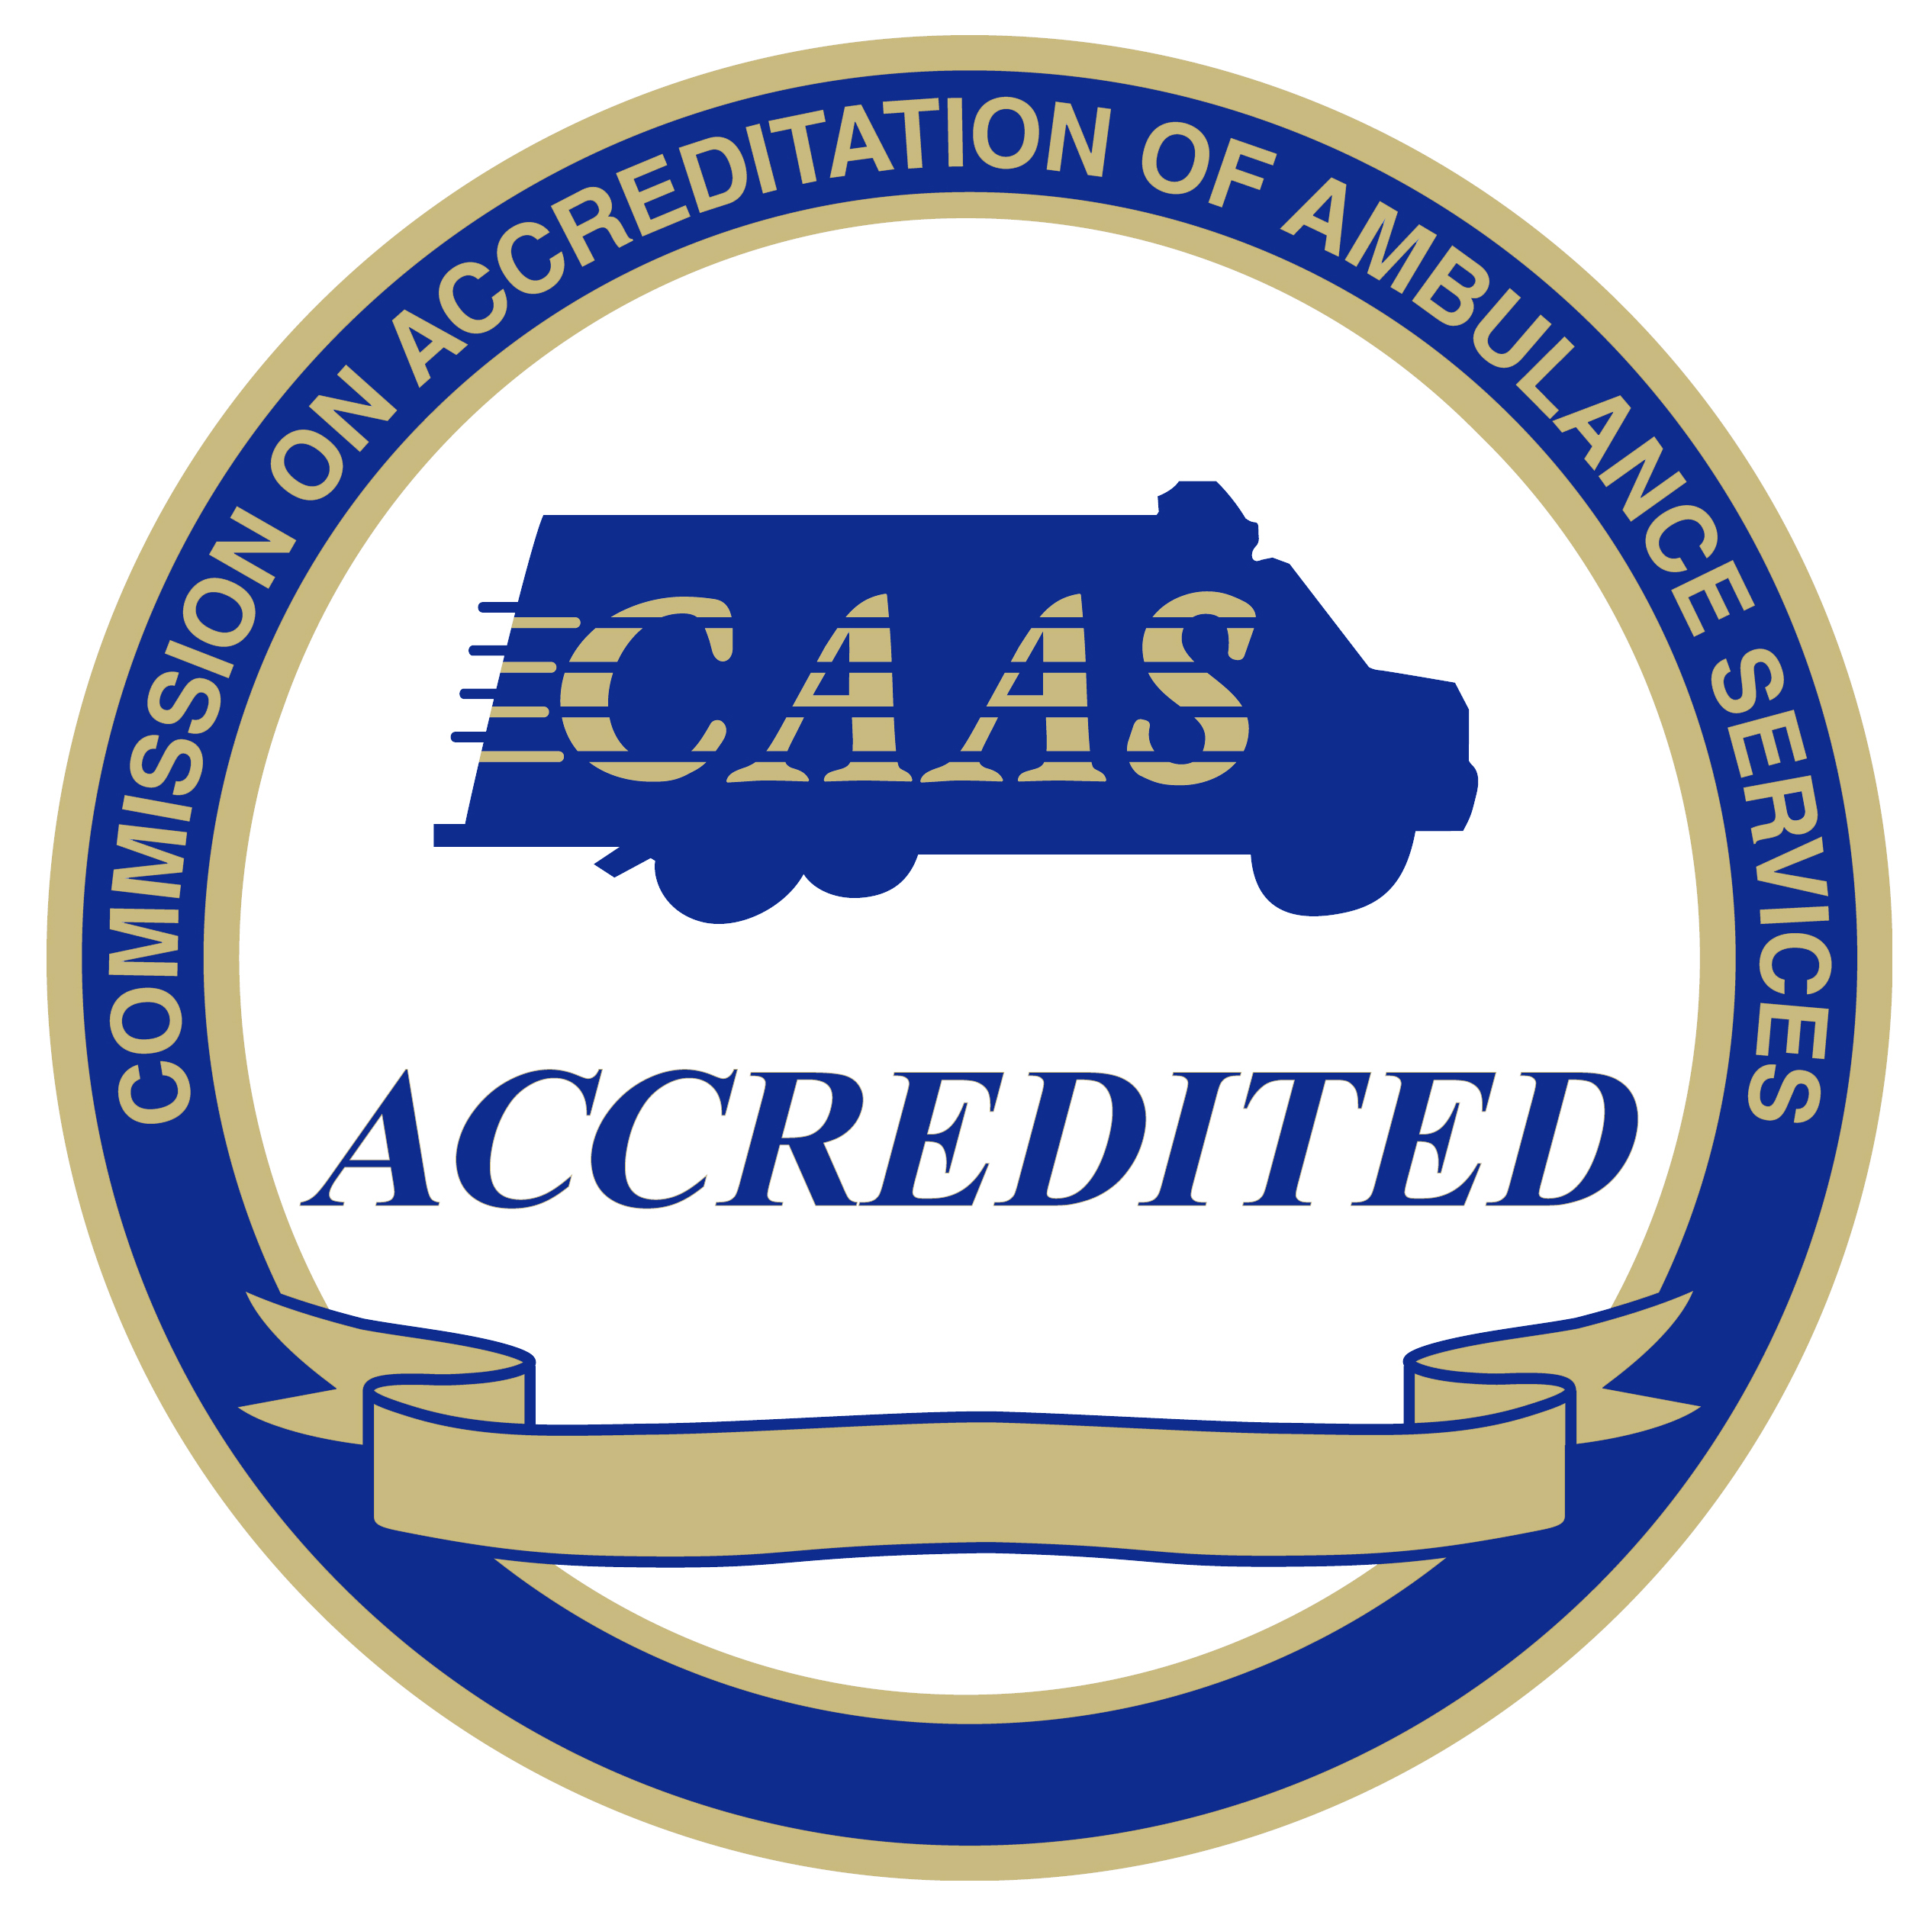


Fire Chief

Supplemental Essay Questions

In order to get a better sense of your writing skills and additional insights into your experience, please answer the following questions. Limit your responses to no more than a single page per question and upload your answers as part of your online application by October 1, 2023 (first review, open until filled).

- Please tell us why you are interested in this position and why it is a good time in your career to come to the Red, White and Blue Fire Protection District.

- The entire District sits in the wildland urban interface. With increased temperatures, drought, and human factors, the area has significant catastrophic wildfire potential. Please give a brief overview of your experience building on prevention, mitigation, education, and community planning efforts to address such a scenario, or a similar scenario.

