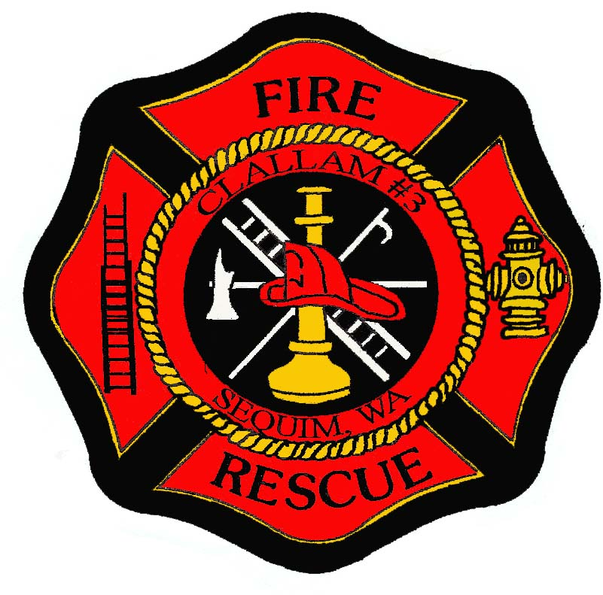

Fire Chief

Supplemental Essay Questions

In order to get a better sense of your writing skills and additional insights into your experience, please answer the following questions. Limit your responses to no more than a single page per question and upload your answers as part of your online application by October 15, 2023 (first review, open until filled).

- Please tell us why you are interested in this position and why it is a good time in your career to come to Clallam County Fire District 3.

- The new Fire Chief will ideally have experience developing and managing a fleet and facilities plan to include relocation and managing fire station remodel projects. Please give a brief overview of your experience in this area, or experience in developing and managing similar plans.

