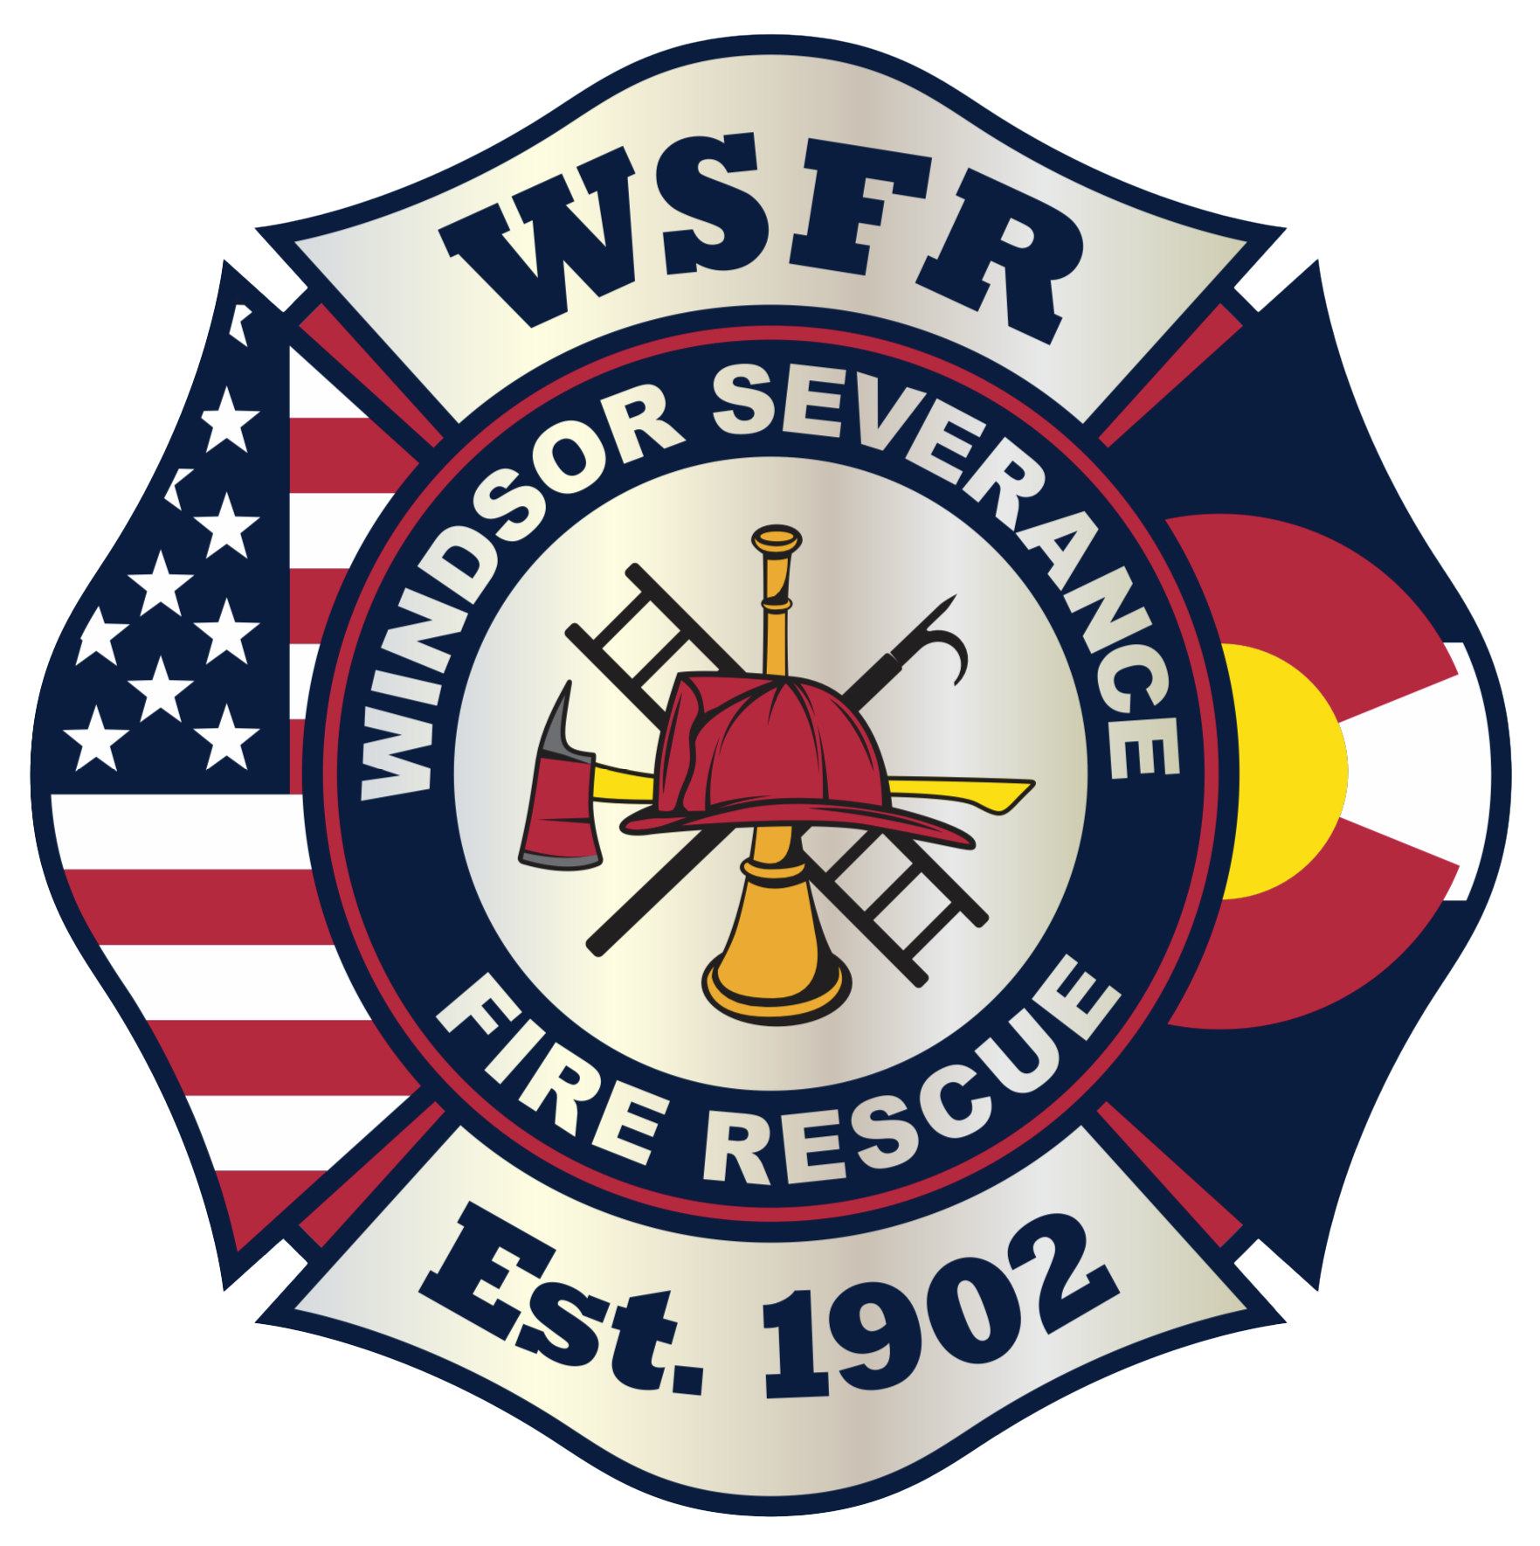

Fire Chief

Supplemental Essay Questions

In order to get a better sense of your writing skills and additional insights into your experience, please answer the following questions. Limit your responses to no more than a single page per question and upload your answers as part of your online application by October 22, 2023 (first review, open until filled).

- Please tell us why you are interested in this position and why it is a good time in your career to come to Windsor Severance Fire Rescue.

- The incoming Fire Chief is expected to get to know the staff, collaborate and develop a clear vision for the future of the organization, and begin the process to address some succession planning needs to address turnover in some key leadership positions. Please give an overview of how your experiences in these areas would allow you to be successful at Windsor Severance Fire Rescue.

