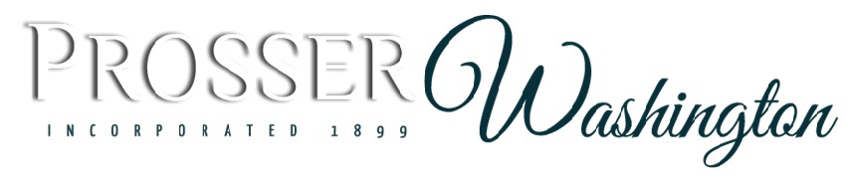
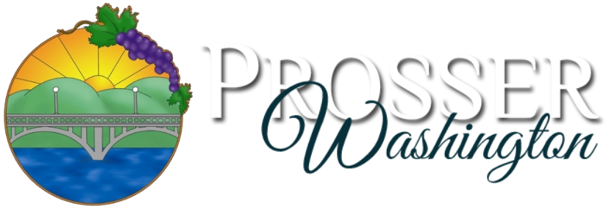

Planning & Community Development Director

Supplemental Essay Questions

In order to get a better sense of your writing skills and additional insights into your experience, please answer the following questions. Limit your responses to no more than a single page per question and upload your answers as part of your online application by March 16, 2025. Open until filled. Applications reviewed as submitted.

- Please tell us why you are interested in this position and why it is a good time in your career to come to the City of Prosser as their next Planning & Community Development Director.

- Please briefly describe a planning or community development project that you have led or managed that significantly impacted a community.

