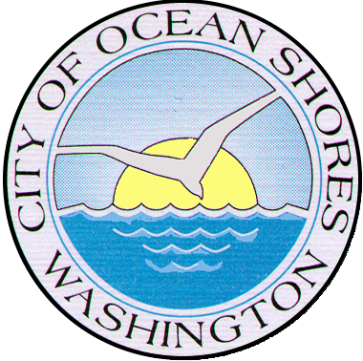


Deputy Chief of Police

Supplemental Essay Questions

In order to get a better sense of your writing skills and additional insights into your experience, please answer the following questions. Limit your responses to no more than a single page per question and upload your answers as part of your online application by June 15, 2025 (first review, open until filled.)

- Please tell us why you are interested in this position and why this is a good time in your career to come to the City of Ocean Shores as their next Deputy Chief of Police.

- The City of Ocean Shores is seeking a Deputy Police Chief who may step into the Chief’s role upon the current Chief’s planned retirement in April 2026. Please describe how your leadership style, experience working within politically diverse communities, and commitment to impartiality could prepare you for this transition. What strategies would you use to gain the trust of the department, city leadership, and the community as a future Chief?

- One of the department’s most significant upcoming projects is the planning and development of a new police station. Please describe your experience with capital project planning and implementation that would prepare you to take on this project.

