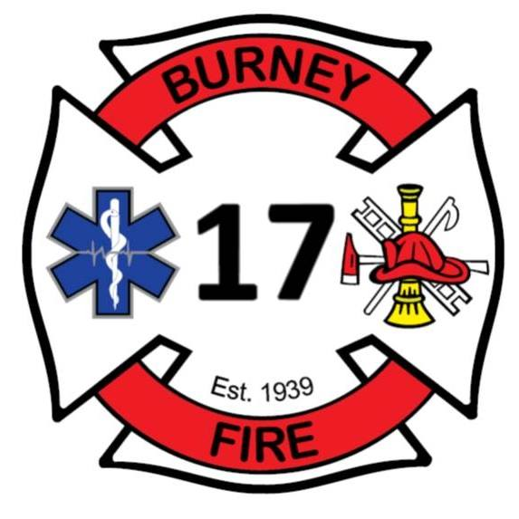
Burney Fire
Protection District
California

Fire Chief

Supplemental Essay Questions

In order to get a better sense of your writing skills and additional insights into your experience, please answer the following questions. Limit your responses to no more than a single page per question and upload your answers as part of your online application by June 22, 2025 (first review, open until filled).

- Please tell us why you are interested in this position and why it is a good time in your career to come to the Burney Fire Protection District as their next Fire Chief.

- The Fire Chief must be a hands-on, working leader who brings vision, initiative, and a genuine interest in all aspects of the organization and its personnel. Please provide a brief overview of your career experience that demonstrates your ability to fulfill this role within the department and transition seamlessly into the position of Fire Chief.

