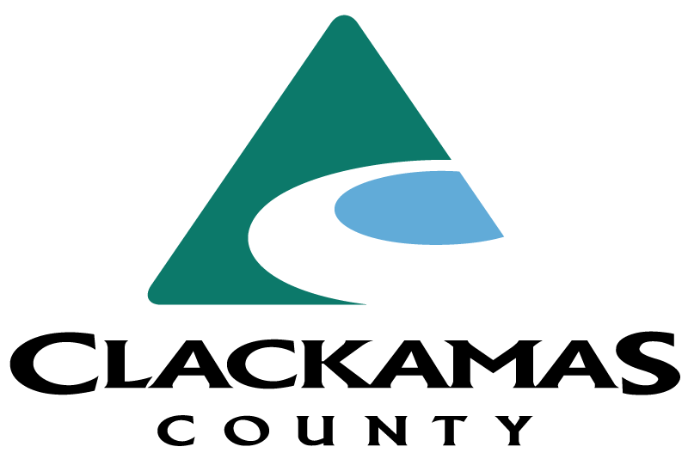

County Counsel

Supplemental Essay Questions

In order to get a better sense of your writing skills and additional insights into your experience, please answer the following questions. Limit your responses to no more than a single page per question and upload your answers as part of your online application by July 13, 2025 (first review, open until filled).

- Please tell us why you are interested in this position and why it is a good time in your career to come to Clackamas County as their next County Counsel

- Please provide a one-to-two-page piece of legal writing which you have written pertaining to a local government issue.

