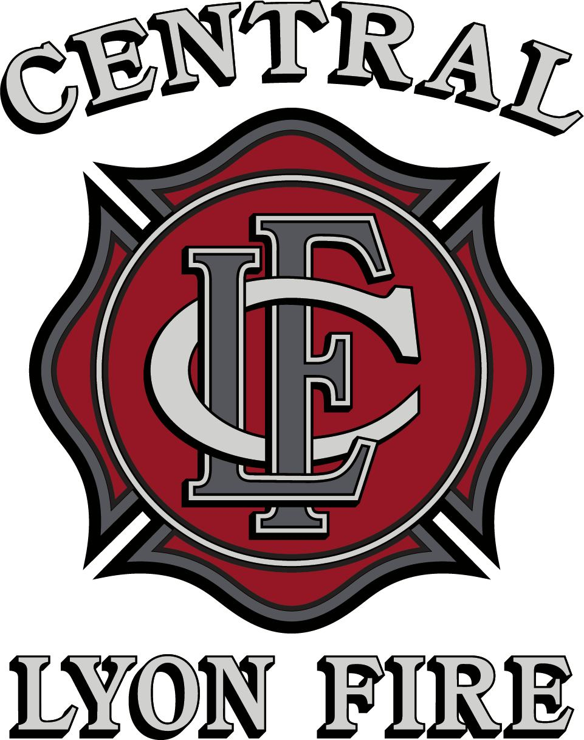

Nevada

Fire Chief

Supplemental Essay Questions

In order to get a better sense of your writing skills and additional insights into your experience, please answer the following questions. Limit your responses to no more than a single page per question and upload your answers as part of your online application by July 20, 2025 (first review, open until filled).

- Please tell us why you are interested in this position and why it is a good time in your career to come to the Central Lyon Fire District as their next Fire Chief.

- How would you approach planning and prioritizing capital improvements for aging fleet and facility needs, given limited resources and potential funding opportunities? Please give a brief overview of your previous experience with capital improvements and provide examples of the strategic and financial considerations you would incorporate into your planning process.

