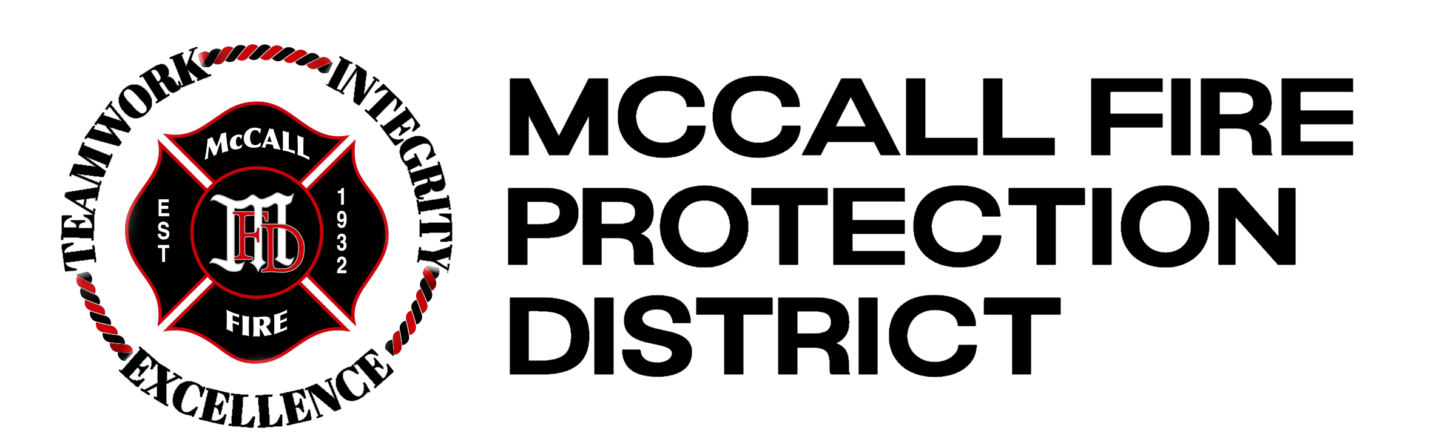

Deputy Fire Chief

Supplemental Essay Questions

In order to get a better sense of your writing skills and additional insights into your experience, please answer the following questions. Limit your responses to no more than a single page per question and upload your answers as part of your online application by September 21, 2025 (first review).

- What have you learned about the McCall Fire Protection District that interests you, and why is now a good time in your career to consider this opportunity?

- Please describe an instance when you led or contributed to a major organizational change in fire, EMS, or a similar operational setting. How did you involve stakeholders and allocate resources to achieve a successful outcome?

- The District is growing its staff and emphasizing strong labor-management relations. Please describe strategies you have implemented to strengthen workforce development, enhance well-being, or improve recruitment and retention. How have you evaluated these strategies’ effectiveness?

