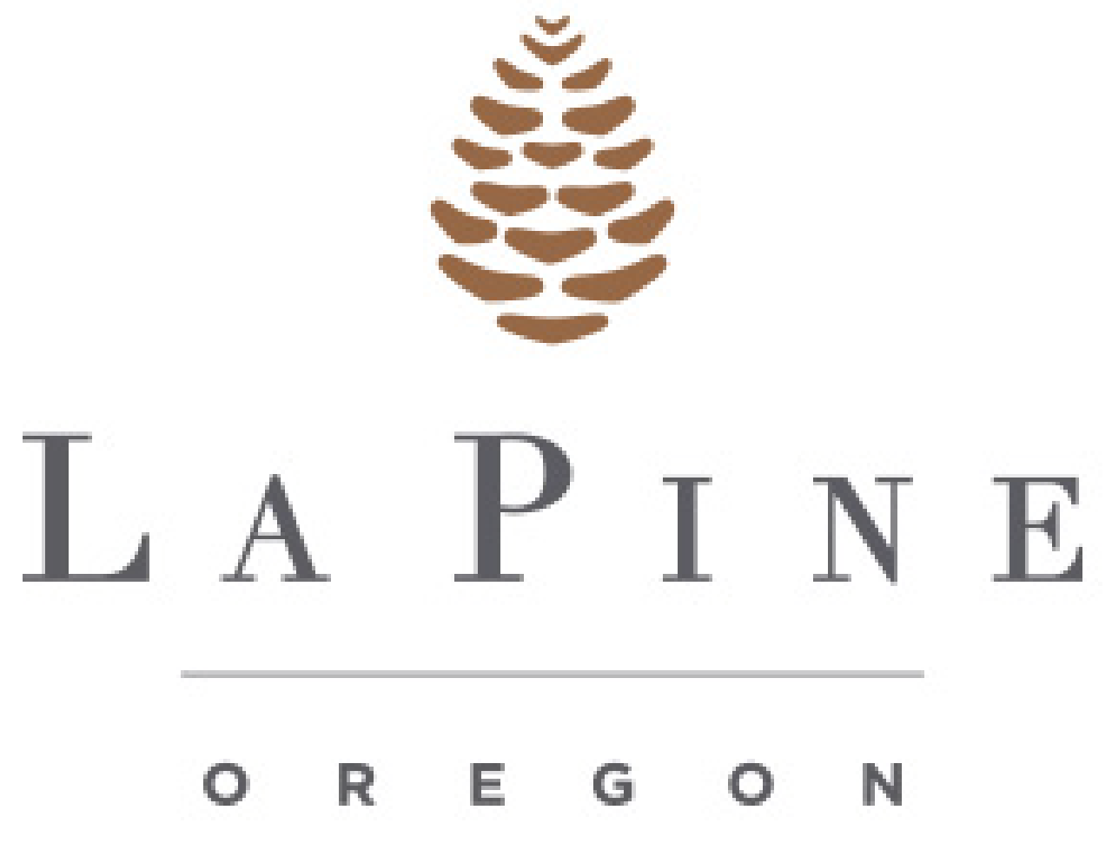

Public Works Director

Supplemental Essay Questions

In order to get a better sense of your writing skills and additional insights into your experience, please answer the following questions. Limit your responses to no more than a single page per question and upload your answers as part of your online application by October 5, 2025.

- Please tell us why you are interested in this position and why this is a good time in your career to come to the City of La Pine as their next Public Works Director.

- Please describe your experience collaborating with local government agencies and stakeholders on comprehensive land use planning or master plan updates. What has been you approach to engaging multiple parties in the planning process and how you would work to shape a master plan that balances development opportunities with community values and growth management?

