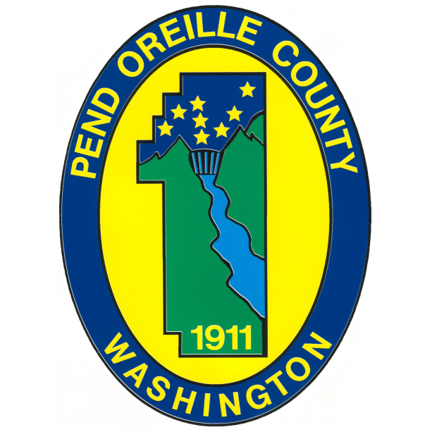

Public Works Director / County Engineer

Supplemental Essay Question

In order to get a better sense of your writing skills and additional insights into your experience, please answer the following question. Limit your response to no more than a single page and upload your answer as part of your online application by October 26, 2025 (first review, open until filled).

- Please tell us why you are interested in this position and why it is a good time in your career to come to Pend Oreille County as their next Public Works Director/County Engineer. How does your experience align with the requirements of this position?

- Pend Oreille County is seeking a Public Works Director/County Engineer who can cultivate a strong workplace culture and lead the organization through change, while ensuring efficiency and high-quality service. What is your leadership philosophy during times of transition, and how would you apply it to foster alignment, strengthen collaboration, and position the department for long-term success?

