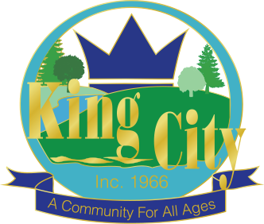

City Manager

Supplemental Essay Questions

In order to get a better sense of your writing skills and additional insights into your experience, please answer the following questions. Limit your responses to no more than a single page per question and upload your answers as part of your online application by October 26, 2025 (first review, open until filled).

- Please tell us why you are interested in this position and why this is a good time in your career to come to the City of King City as their next City Manager.

- Describe your approach to building a responsive and collaborative city organization. How would you foster a culture that values citizen input, build and sustain fair partnerships with external stakeholders, and effectively communicate City Council goals to both staff and the community? In your response, share specific strategies you have used to listen to community concerns, promote shared understanding, and develop actionable solutions that align with organizational priorities.

