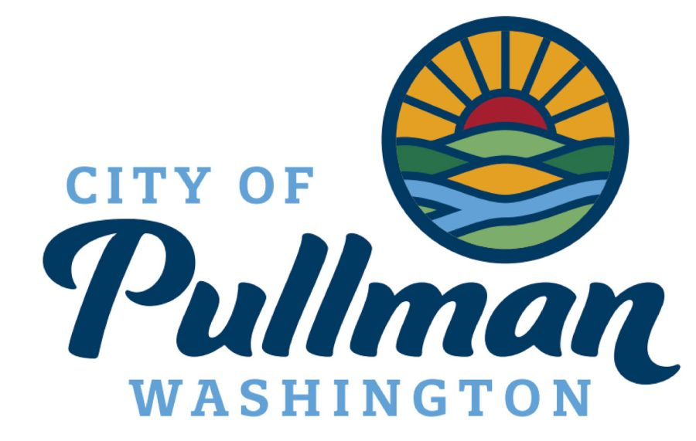

Public Works Director

Supplemental Essay Questions

In order to get a better sense of your writing skills and additional insights into your experience, please answer the following questions. Limit your responses to no more than a single page per question and upload your answers as part of your online application by October 26, 2025 (first review, open until filled).

- Please tell us why you are interested in this position and why it is a good time in your career to come to the City of Pullman as their next City Administrator.

- With over 400 employees and seven labor groups, Pullman is looking for a leader who can support and develop staff across all levels of the organization, while fostering a collaborative, positive, and accountable workplace. Please give a brief overview of your experience in managing and motivating teams, maintaining labor relations, and building a culture of consistent and clear communication.

